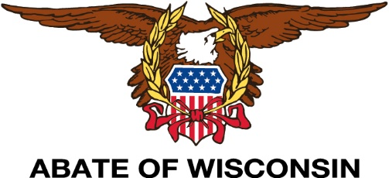
“The Motorcycle Issue Experts”
“The Taste of Summer at The Hummer”

June 18, 2022

Welcome to the Taste of Summer at the Hummer,

We are looking for participation from Breweries, Wineries, Cheese Makers & Meat Markets throughout Wisconsin to “Promote their Products” during our 3-hour tasting at ABATE of Wisconsin’s 2022 Summer Hummer.

ABATE of Wisconsin’s “Summer Hummer” is an annual event with live music, games, entertainment & camping. For the past 15 years THOUSANDS of people have attended this event. The Summer Hummer is a “Biker Rally” OPEN TO THE PUBLIC (21+ years & older) and takes place on ABATE ACRES which is located 13 miles south of Thorp, WI. at W8742 Capital Rd., Greenwood, WI. It is a beautiful 80-acre complex equipped with a modern bathroom and shower facility.

ABATE of Wisconsin is willing to purchase up to (4) - 12 pack cases of beer (not to exceed a total of $150.00) from each brewer and 2 cases of wine (not to exceed a total of $250.00) from each winery that participates.

We ask vendors to have enough samples for 200+/- attendees. Booths (10’ x 10’) are FREE to vendors (includes 2 gate passes for employees) but are limited to a “first come basis”. ABATE will also provide ice if needed, as no electricity will be provided. Non-alcoholic vendors are welcomed to sell their product as well, providing the vendor complies with WI state laws. We are asking each vendor to help promote this event and to do so are offering each vendor a special “Vendor Tasting Packet” which includes (5) Gate Day Passes (passes include camping and Saturday night live music) along with (5) “Taste of Summer” Passes (valued at $250.00) for a donation of $150.00. You may sell them at your locations OR give them away to your “VIP customers”. We also ask that you post this event on your social media sites.

There is no other event like this in the area AND we want YOU to join us!!!

Please fill out the “Taste of Summer at the Hummer 2022” vendor registration form and return it to reserve your booth. Once your reservation is received, we will contact you. Please Mail applications to:
Laurie Thompson – Taste of Summer
1423 S. 169th Street
New Berlin, WI 53151

Thanks in advance for supporting “The Taste of Summer at The Hummer 2022!”

Dawn Stoddard
ABATE of Wisconsin
Taste of Summer 2022 Coordinator
(920) 639-5037
dawn.stoddard63@yahoo.com

Taste of Summer 2022
June 18 ,2022 - Set up 11 am - Sampling 12-3 pm
Vendor registration
(Please print)

Date of registration: ______________________________
Business Name: ________________________________________________________________________
Business mailing address: ________________________________________________________________
City, State, Zip: ________________________________________________________________________
Business phone: _______________________________________________________________________
Contact: ______________________________________________________________________________
Title: ________________________________________________________________________________
Contact’s phone number: ________________________________________________________________
Products the business is offering to bring: ___________________________________________________
_____________________________________________________________________________________
Any “special needs and/or requests”: _______________________________________________________

Number of “Vendor Tasting Packets” requested at $150 each: # ________ X $150.00 = $____________
Mail To:
Laurie Thompson – Taste of Summer
1423 S. 169th Street
New Berlin, WI 53151

Thank You,

Dawn Stoddard
ABATE of Wisconsin
Taste of Summer 2022 Coordinator
(920) 639-5037
dawn.stoddard63@yahoo.com

