SUMMER HUMMER 2023
JUNE 15 – 18, 2023
Are you planning on attending ABATE of Wisconsin’s Summer Hummer? Need a shirt?
Complete this form and send with payment (check or money order payable to ABATE of WI)
To: ABATE Products, c/o Bob Christopherson, 1312 Hodkiewicz Road, Pulaski WI 54162
ORDER MUST BE RECEIVED BY MAY 22, 2023.

NAME: ____________________________________________________________________________

Address: ___________________________________________________________________________

City: _______________________________________ State: _____________ Zip: _______________

Please provide evening phone number/email address

for questions about order: _____________________

QUESTIONS?? CONTACT Bob at (920) 639-8110 or
products@abatewis.org

Available Sizes:
Small, Medium, Large, X-Large, 2 X-Large
3 X-Large and 4 X-Large
Grey T-Shirt

Back Front Left Chest
Summer Hummer 2023 T-Shirt Order | How Many? | Size | Cost Each | Total
Short Sleeve T-Shirt |  |  | $20.00
Short Sleeve T-Shirt |  |  | $20.00
Short Sleeve T-Shirt |  |  | $20.00
 |  | Shipping 1 or 2 Items | $9.00
 |  | Shipping 3 or More Items | $12.00
Total Order With Shipping

**NOTE** NO Shipping Charges if you are picking up at the Summer Hummer
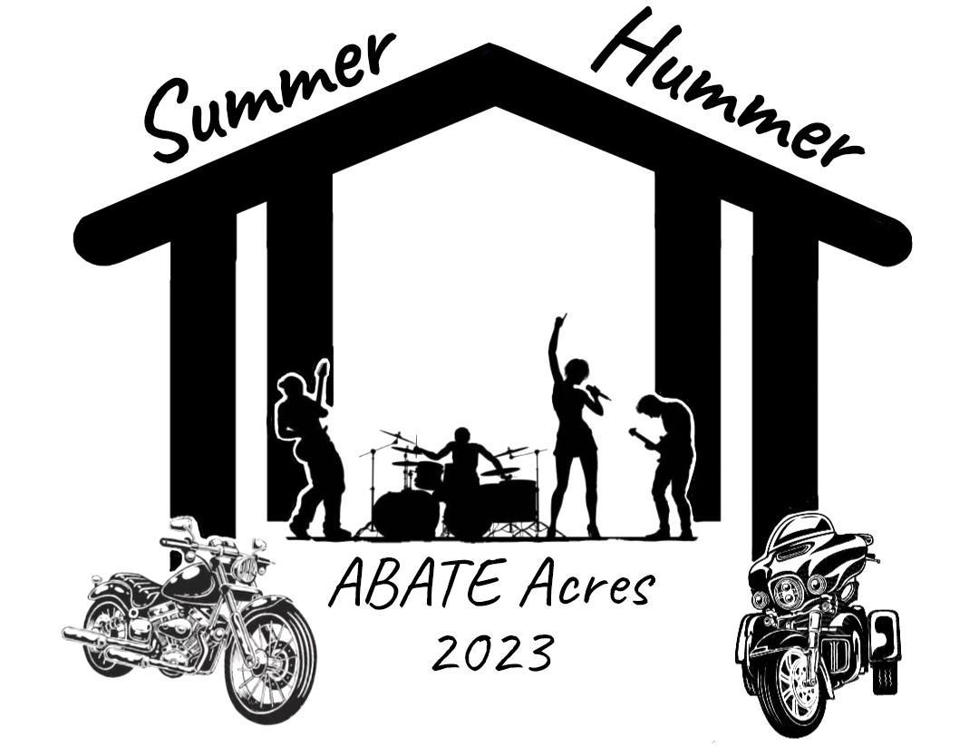
Please check if you are picking this order up at the Summer Hummer _________________
Left Front Chest
ABATE of Wisconsin
2023 Summer Hummer

